|  |  |
| --- | --- |
| **https://lh4.googleusercontent.com/AcqUisf9rNpHzpW7PXyIdDoTltWj65-rBCIJiTnyzpZJPJMmxHz4A7C9807HuZ-iG1EULkuAWTuyBG1kqdJ8APDoQ6ff2U2Kvk6DA31cdAACGPIXd9kPEEHzzfSaltp8WNcH-206** | **Project Report**  **-Q-POS Inventory Management System**  **Innovative Inventory Solutions** |
|  |  |

|  |
| --- |
| https://lh6.googleusercontent.com/HfZtMq8UWURKU1LQ7lH6ZGz_5WMcoXb7jSVaLMlm7lAIdq6Rc0XI6kUvm51fQ47QbeBf43HmNECrAvZAHPVsz-6hq_05mPLdbH35HUb-jOMLTNW2VbiBgzPJwo-2RnTqkTQ4Nr_s |

**GROUP:**

Md.Dedarul Hasan- Reg: 0417311011,

Zubayer Al Mahmud- Reg: 1017311014,

Student, PGD in ICT ,IICT-BUET.

|  |  |
| --- | --- |
| **https://lh6.googleusercontent.com/sS0FClSy-q0hyvw2cn4dgANx7Pjt_hz7PFhLUeaAAH9H3PExogFlSsE9_JdMFm6f5oW77p_a1fSjGqiB2z1ghqsVJAGzjTu-f6L1hUmAr6rPp7vEP0tR2eiIjS_Ro4gj38Q_VUDV** | **https://lh3.googleusercontent.com/IMMJaQ7Hlfmiv1R9qeof49B40CYKtRLmHU6MhRsiD5IiW3MMd9ivGmMz9Er9zG_dLgPX96h8jXuE7nsFz5s63Phw5CA6BfxlUY5sSCLIjUqsQk_34FdKzBHw-KgrJvBAU6mdmi5k** |

**ACKNOWLEDGEMENTS:**

We would like to thank Md.Arifuzzaman Sir, Hossain Asiful Mustafa Sir & Md.Rubayet Hossain Mondol Sir, IICT- BUET for their best class input, feedback & support activity to perform us to inspire as well as to do different work to make our product a successful one.Their experience in the Programming Application Development, Software Architecture Design [UML] & Database Design effort and teaching technique which is fruitful and extensive when it came to the project requirements and development.

**[PAGE INDEX]**

Acknowledgements……………………………………………………………….2

1. Introduction…………………………………………………………………………… 4

1.1 Purpose Of Q-POS …………………………………………………………..4

1.2 The Goal Of Q-OS …………………………………………………………..4

1.3 Domain Of Q-POS …………………………………………………………..5

1.4 Clients Of Q-POS ……………………………………………………………5

1.5 Users …………………………………………………………………………5

1.6 Application…………………………………………………………………...6

1.7 Objectives & Success Area ………………………………………………….6

2. Project Literature……………………………………………………………………….7

2.1 Front..………………………………………………………..…………….....7

2.1.1-Installation…………………………………………………………8

2.1.2-Main Window……………………………………………………..9

2.1.3-Signup…………………………………………………………… 10

2.1.4- Show Users Info. ………………………………………………..11

2.1.5- Print Users Info. …………………………………………………12

2.1.6-Login…………………………………………………………..….13

2.1.7-Inventory………………………………………………………….14

2.1.8-Purchase…………………………………………………………..15

2.1.9-Show Purchase Info. ……………………………………………..16

2.1.10-Sales / Order ……………………………………………………17

2.1.11-Show Order Details …………………………………………….18

2.1.12-Logout Options …………………………………………………19

2.2 Back-End…………………………………………………………………….20

3. Methodology & Design………………………………………………………………..21

3.1 Basic Database Relationships……………………………………………….21

3.2 Erd For Inventory Management Database…………………………………..22

3.3 Detailed System Design…………………………………………………….23

4. Analysis……………………………………………………………………………….24

4.1 Requirements Analysis……………………………………………………...24

4.2 Debug & Testing…………………………………………………………….25

5. Result & Discussion………………………………………………………………...…26

6. Materials And Ide-Tools………………………………………………………………26

7. Process Improvement………………………………………………………………….26

8. Future Development…………………………………………………………………..26

9. Conclusion…………………………………………………………………………….27

10. Reference ……………………………………………………………………………27

**1. Introduction:**

Quick POS Inventory Management System is use to track inventory ,sales process, orders & delivery product system. It may can be utilize to generate production related documentation work such as orders & bill of materials, Any company make use of this system to avoid overstocking of products and outages. Quick Inventory Management System Software offers an improved way to organize yours inventory information compared to spreadsheets or paper. This Solution resembles distribution software because it helps distributors spend less money on inventories,Thus giving them an edge over competitors; Main features of this application include order management, asset tracking, service management and product identification.Start by checking our leader NetSuite ERP.

**1.1 Purpose of Q-POS :**

A case study at Q-POS (Lily IT) Cited issues regarding a basic resources requirement list that has to be maintained manually by the stuff.To keep track of their inventory levels they have to calculate a list of the groceries utilized during a course of time, calculate and analyze the requirements for the future and place their order to the vendors if needed.This process takes up a lot of time and human effort and is also prone to human error.

This process a problem of a situation that the sales keeper of a mini shop as well as many other shops faces. It takes up a lot of time to manually keep track of sales and place correct orders to vendors ,wasting useful labor in trivial works.A product which would assist in tracking the above mentioned problems would prove to be fruitful to clients such as Q-POS & similar enterprises as this product would help convert the unproductive time to something more useful, by removing the unnecessary error prone complications & efforts

**1.2 The Goal of Q-POS :**

The project aims at providing an efficient interface to the mini shop markets for managing their grocery inventory base on each item sold.The basic idea involved here is that each item is linked to its atomic ingredients which are stored in a database.At the end of each day ,the system analyzes the total sale of menu items & proportionately deducts appropriate amount from the resource database.Then it compares the current available resources with the appropriate amount from the resource database.Then it compares the current available resources with the threshold level of each ingredient.If it finds that certain ingredients are below the threshold ,it will generate a purchase order for those items & send it to the manager [admin] for approval.

We also propose to include a special feature "prediction".This feature keeps track of any upcoming occasions,climatic changes & special events that may influence inventory needs for the upcoming week.The system will then predict the required resources an updated purchase order in accordance with the predictions.

The product also aims to keep track of the shelf life of resources.If any resource nears the end of its shelf life, it would intimate to manage[admin] the details of the quantity that is near its expiration date.The Q-POS must function efficiently, the groceries must be tracked correctly, timely orders must be sent out to the vendors, & the inventory must be maintained and updated at all times.

**1.3 Domain of Q-POS :**

This proposed project aims at inventory control in the small & mini shop business.Such a large domain would result in an equally as large scope of developmemt.As a result we narrow our software down to our case study of an outlet of Q-POS inventory system concentrating only on the basic resources utilized in inventory control of the outlet.Although the software will be developed keeping in mind the needs of purchase & sale as well as data at first,then applying it to the larger domain of the entire mini shop retail system can be achieved with case.

Our target domain is full of software to track sales of products for mini shop keeping business but lacks in this area of inventory management.Our software can be scaled from large corporate level all the way to small privately owned mini shop markets.It is also fairly domain specific :the database runs off recipes which generate the necessary ingredients.It also updates the inventory based off of sale of those items /products.This requirement focuses our product to our domain & makes it more appealing to those looking for a solution to this specific problem.

**1.4 Clients of Q-POS :**

The client can vary from private shopping mall or corporate super markets such as ALORON Febrications.A corporate shopping mall which consists with huge number of shops which starts up, staffs & oversees the everyday workings of a corporate super market, such as the one in the Newmarket supermarket/Bashundhara super market.As stated above ,while our product can be applied to the entire domain of the shoping complex clothing or footwear business , focusing on a specific business provides us with more precise & consistent data.A shopping company such as Bashundhara would be an ideal client, as the staff multiple corporate shops across the nation.A large scale company such as this can apply our software to each and every mini shops which cutting down costs on a very large scale.

Our application will allow our client to customize the database to suit the needs of each mini shop individually.They can vary in recipes of item/products that can be customized at a smaller scale.Our client would need to purchase multiple licenses, or more likely a corporate subscription that would allow them to use the software in multiple mini shops.We would also offer single use licenses to appeal to super markets which owned many number of mini shops that only need to manage a single inventory of goods.

**1.5 Users :**

The main user of the product would be mini shop retailer and staff as sales person itself.The management would approve  the orders that would be sent out, provide vendor information, upload or select customers recipes and set threshold levels.

Many of these tasks, such as the information regarding vendors, recipes, and threshold levels would need to be set only once.Of course ,the option to add ,remove or update this data would be implemented as well.Once this initial step has been taken ,our software will require nothing more than a weekly approval for the orders being sent out ,minimizing the work that Q-POS has to complete in order to insure the correct amount of inventory is available.

Stuff or employee sales person himself would be responsible for updating the amount of  product sold at the end of the day. Each day ,the register prints out the products sold and the quantity of each product sold.Instead of manually subtracting that amount from inventory ,they input the amounts sold into our  software which will do the number of chosen for them.This data is also stored into the predictions features for future use.

**1.6 Application:**

* Super Shop
* Service center
* Cold storage
* Production house
* Mill & Factore
* Buying house
* Small business

**1.7 Objectives & Success Area :**

The objective of our project is to provide an efficient inventory control whose main functionality apart from calculating the inventory include predicting the shop for the next order & also if there is a "special occasion" then accordingly the manager selects the particular occasion & extra requirements is added to the next issuing order to the vendor or customers which needs to be approved by the manager or sales executive.The product also aims to keep track of the shelf life of resources.If any resource nears the end of its shelf life,it would intimate to the manager[admin] the details of the quantity that is near its expiration date.

Success depends on that -

* -accuracy in maintaining the inventory levels
* -accuracy in predicting the requirements of the next order
* -accuracy in relating recipes to their respective ingredients
* -ease of use when it comes to updating inventory levels and placing orders to vendors.

**2. PROJECT LITERATURE:**

**System Architecture Overview[Development Environment]:**

**2.1 FRONT:**

We have used the user interface, control & database connectivity with java swing framework & JDBC .Which represents an awesome & user friendly UI as well as easy to use. We have given the priority of users first working performance by that design & style.

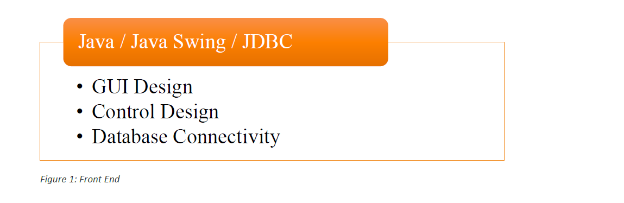

Fig: Diagram of Front End Design Steps

**[2.1.1-Installation]**

If want to use that product firstly you should to configure and given the product key which have to give you the permission with privacy & user authentication by Q-POS installation process step by step.This is the first step to use Q-POS inventory.

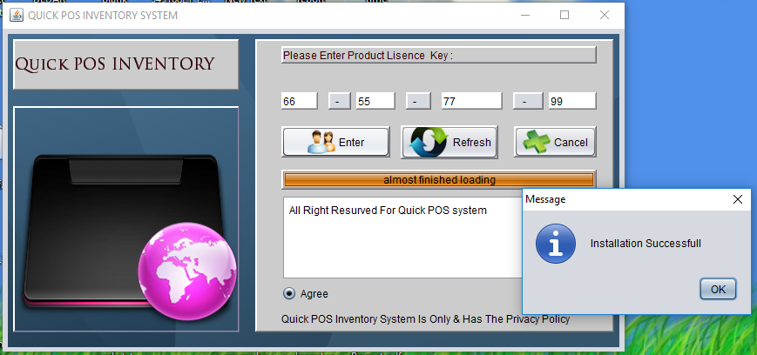

Fig: Installation with product key

**[2.1.2-Main Window]**

After successful installation by the given authorized product key which have to be provided by us you will able to  access the main window of Q-POS.Where you will get some features of our product to use.Before use that you should login the system or exit.

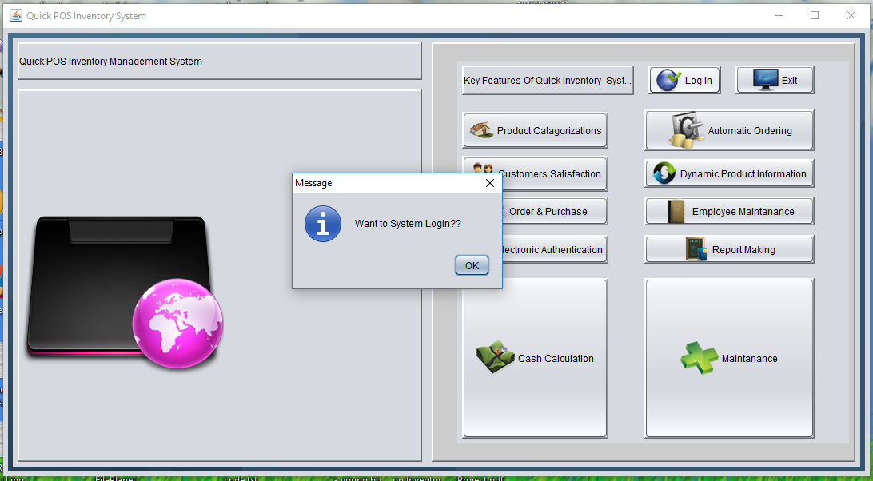

Fig: Main window of Q-POS

**[2.1.3-SignUp]**

To create new user /stuff /employee you can click signup button first at the below of login window then you shall get the sign up window to create new stuff.We have created also the update option where you shall able to re correction or delete or update  by searching specific user by his id.

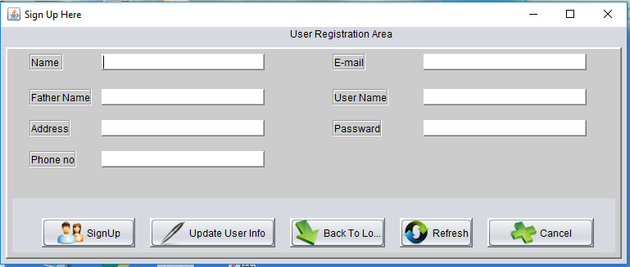

Fig: signup window

**[2.1.4- Show Users Info. ]**

After create a new user, stuff or employee at the user signup widow you shall also able to get or see all user information in a show user table there.This option must maintained by admin or manager.

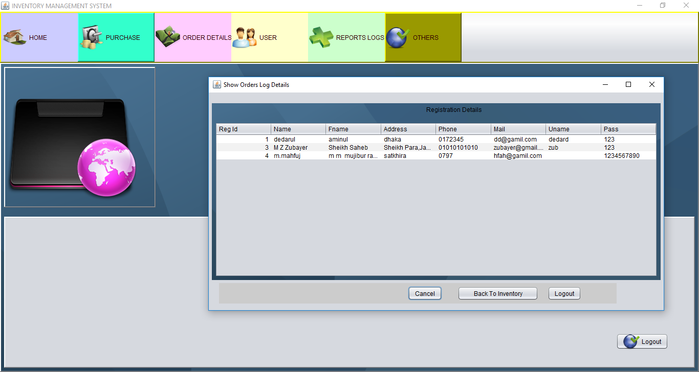

Fig: Show User All Window

**[2.1.5- Print Users Info. ]-using jasper report**

If you or admin or manager want to print  users all information by clicking the print button at update area then you have to get that jasper print.We have used here the jasper report to make that report.

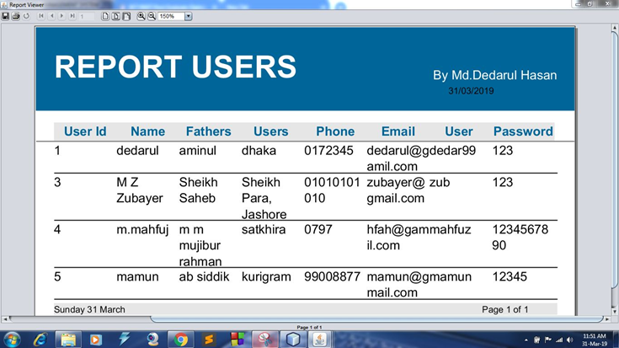

Fig: Users All Print

**[2.1.6-Login]**

After installation Q-POS system and user signup /registration then users will be able to get permission to  access as login area to Inventory for work.We have given the form validation for the right option input the authentication process of users.

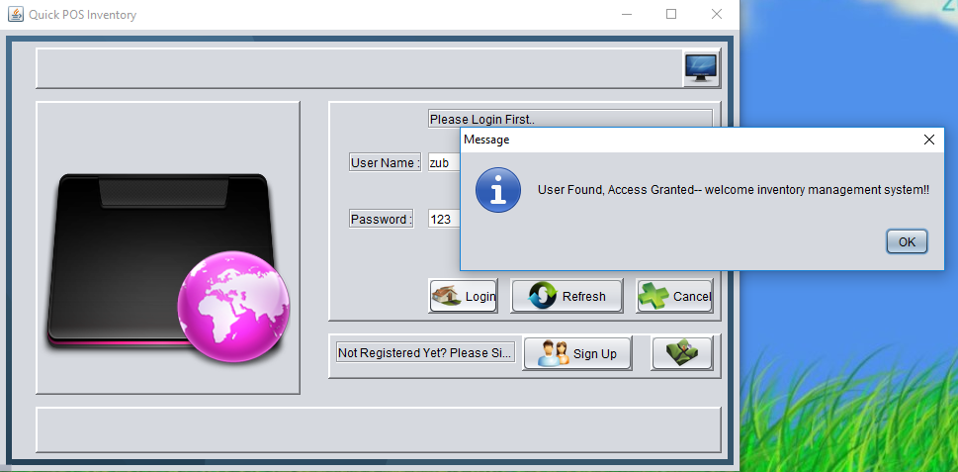

Fig: Login Window To Access Inventory

**[2.1.7-Inventory]**

After completion the login process the user can be able to access the inventory area to do the work of that inventory action of purchase or order.Actually only manager has the permission by admin to create the purchase operations & users has the permissions  to create order & invoice for the customer here.They can change the order form by search customer id to update or remove the order information.

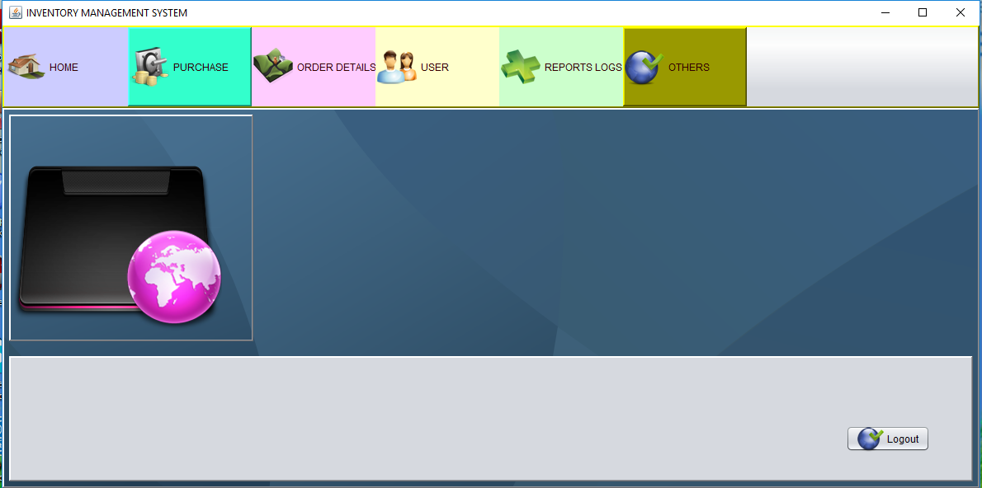

Fig: Inventory Window To Do Work

**[2.1.8-Purchase]**

Admin or Manager can be able to create purchase for new item/ product addition or can make the update ,delete the purchase area also by the create /update/delete option at purchase product system here.We have given the option a quick search option here to modify specific item/product data.

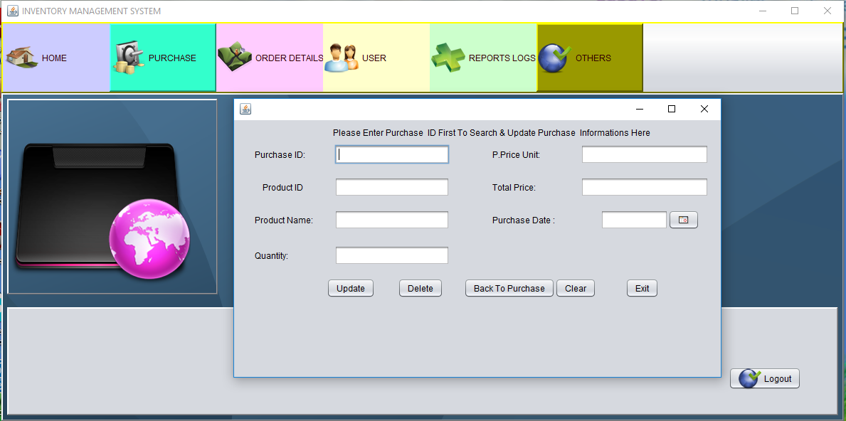

Fig: Add New Item or Product

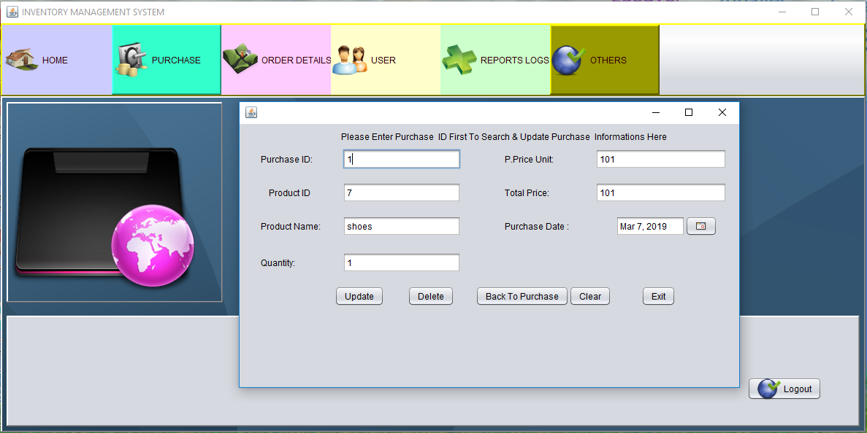

Fig: Update Item/ Product By Id

**[ 2.1.9-Show Purchase Info. ]**

After completion the purchase we can be show the purchased information in details at the show table by click the show purchase table button easily.

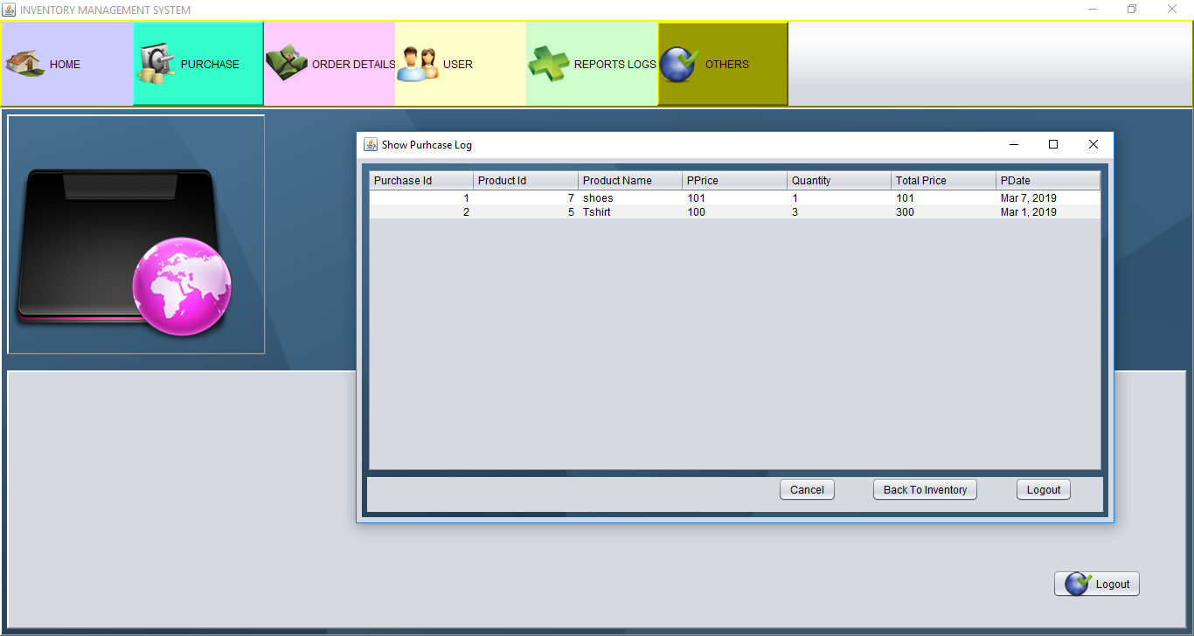

Fig: Show Purchase Info Details

**[ 2.1.10-Sales / Order ]**

After login by the user for a new customer every user or stuff has given the permission to make a new order for a customer or have permission to update, remove customers data to modify by customer id ,at quick search option.

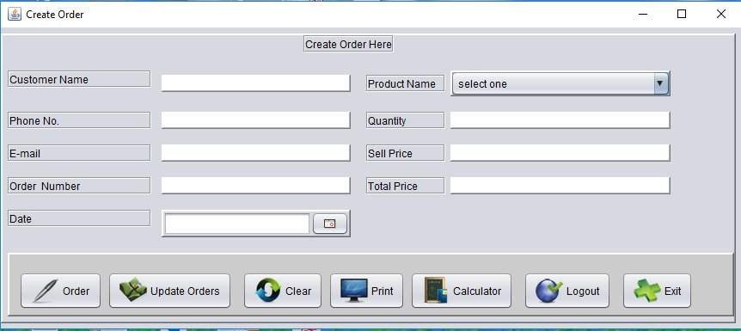

Fig: Create New Order By User

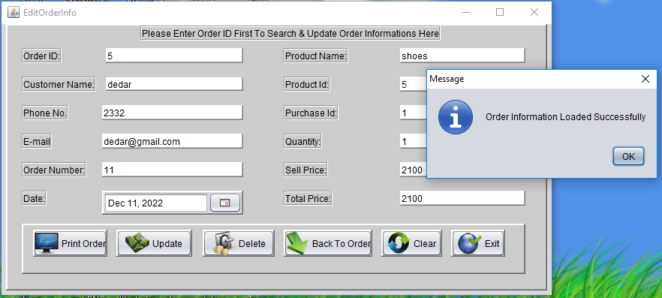

Fig: Order Update or Remove Option

**[ 2.1.11-Show Order Details ]**

Every day after all sales or order information can be shown at the show order table in details by the click button “Show Order” here.

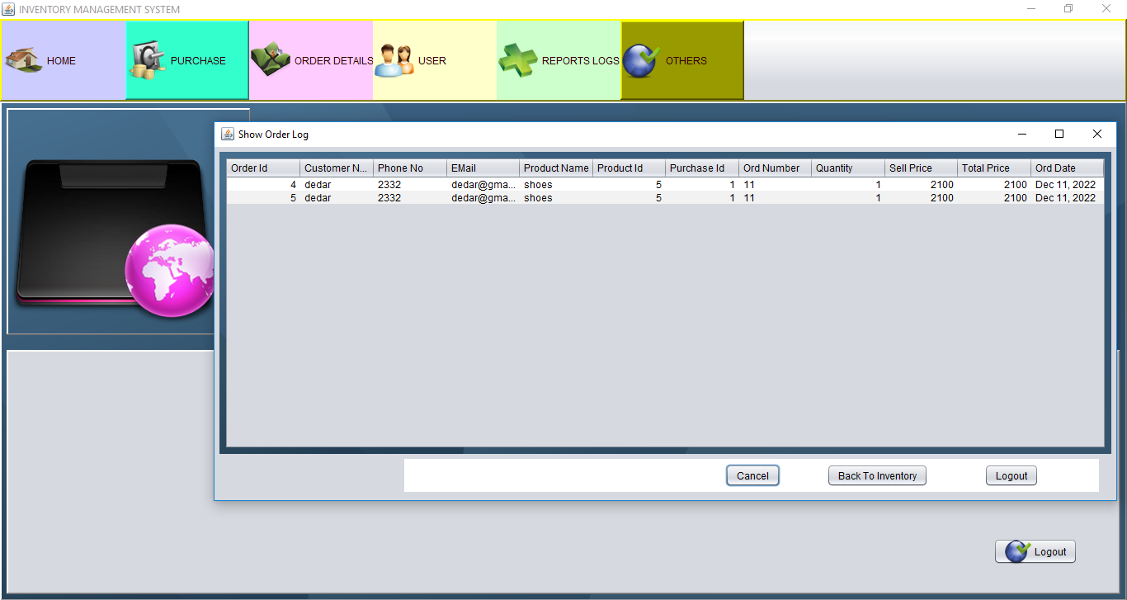

Fig: Show Order Table In Details

**[ 2.1.12-Logout Options ]**

After finish all of work for the inventory system Q-POS you have to log out from the system by submit the logout button.

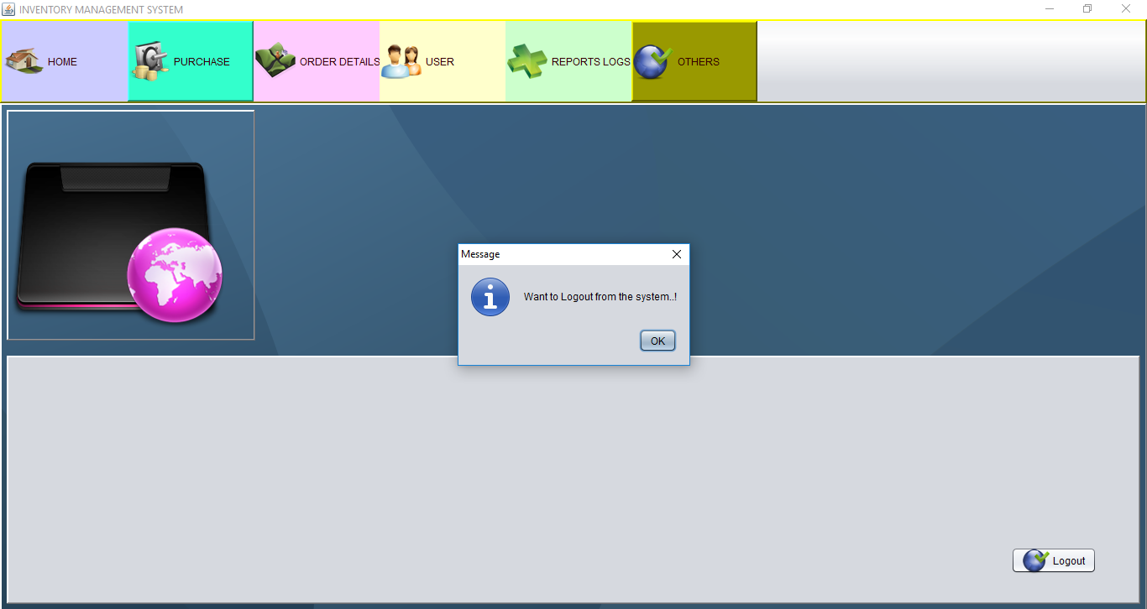

Fig: Logout

**2.2 BACK-END:**

1. Create User
2. Registration.java
3. Login Inventory
4. Login.java
5. Create Purchase
6. Purchase.java
7. Create Order
8. Order.java
9. Update or Delete  User
10. EditRegistrationInfo.java
11. Update or Delete Purchase
12. EdiPurchaseInfo.java
13. Update or Delete Order
14. EditOrderInfo.java

**3. METHODOLOGY & DESIGN:**

**3.1 BASIC DATABASE RELATIONSHIPS:**

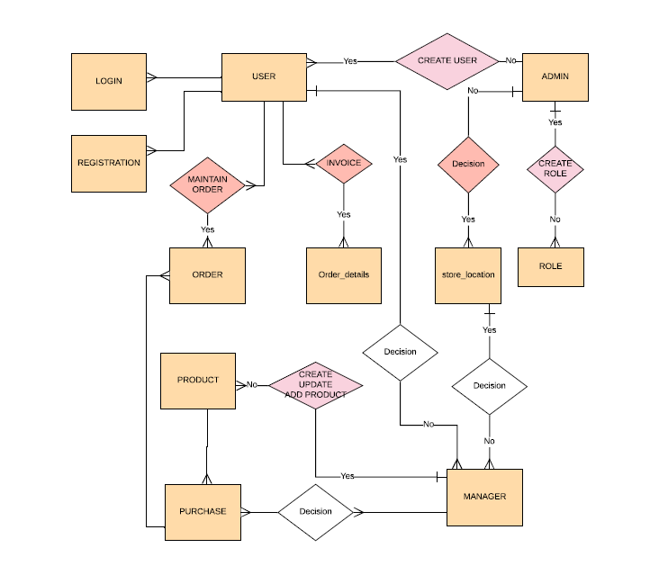

Figure: erd data model

**3.2 ERD for inventory management Database:**

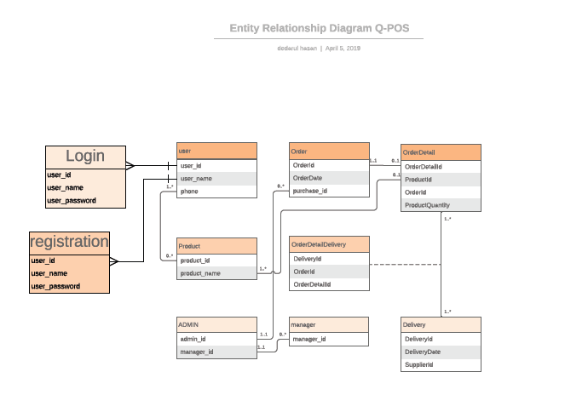

Figure: entity relationship

**3.3 Detailed System Design:**

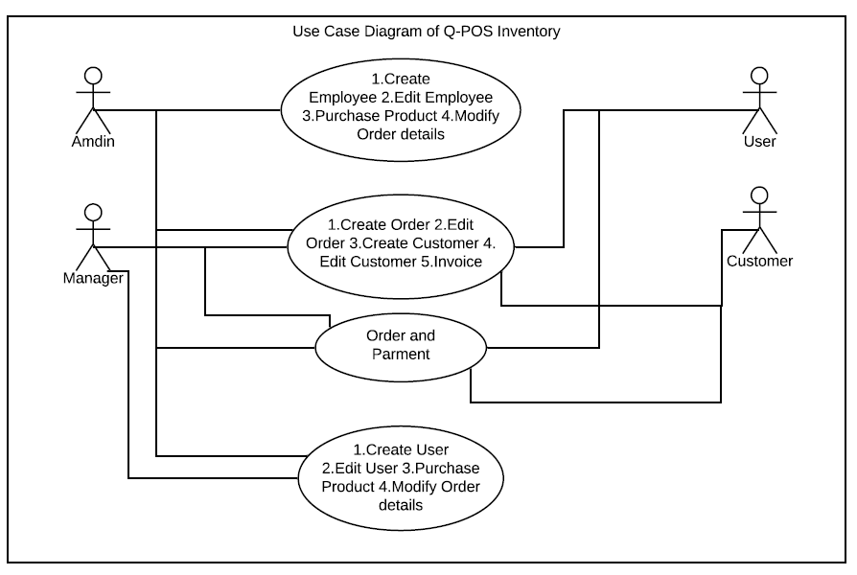

Fig : Use Case Diagram Of Q-POS inventory System

**4. ANALYSIS:**

**4.1 Requirements Analysis:**

The user must have,at disposal, functions for managing the inventory efficiently.

The function for Q-POS inventory system should allow the user to know which ingredients in the inventory are below their threshold levels and need attention

The system must include functions that will allow the user to add a item/products ,ingredient, vendor to the database.

The user should also be able to delete any items/products from the database when not needed.

The system must allow the user to create orders for the ingredients that are below threshold.

The system must include a mechanism for the user so that the user can just update the sales of the day in the system and the system deducts the corresponding amount of ingredient quantity from the inventory.Thus keeping a track fo ingredients.

The system must also include functions for the user to add special days in the system when the inventory usage will be more than usual or less than usual and thus provide a way to alert the user of the possibility of over usage or under usage or certain ingredients.

The system also must provide a prediction function to the user where the system will give the user the predicted usage of inventory of certain pre-set days.

The system must have a password protected access system such that only people with authenticated credential are allowed to access the function of the system.

**4.2 Debug & Testing:**

We have completed that Q-POS system test of functionality by debug test manually line by line & fixed all of problems strongly .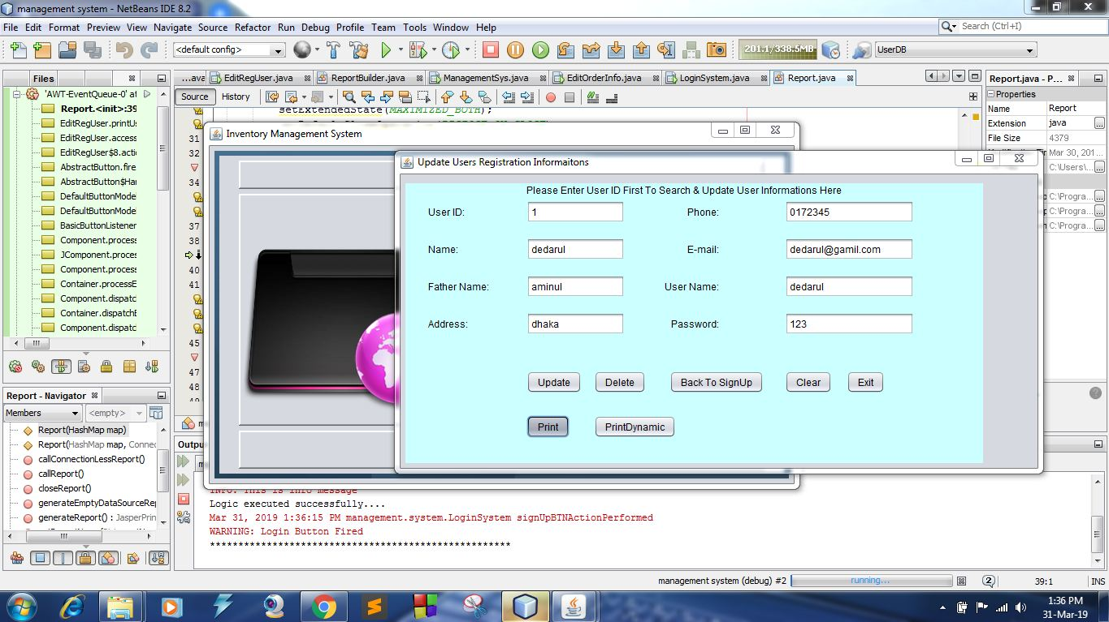

Fig: Debug Run To Test Program

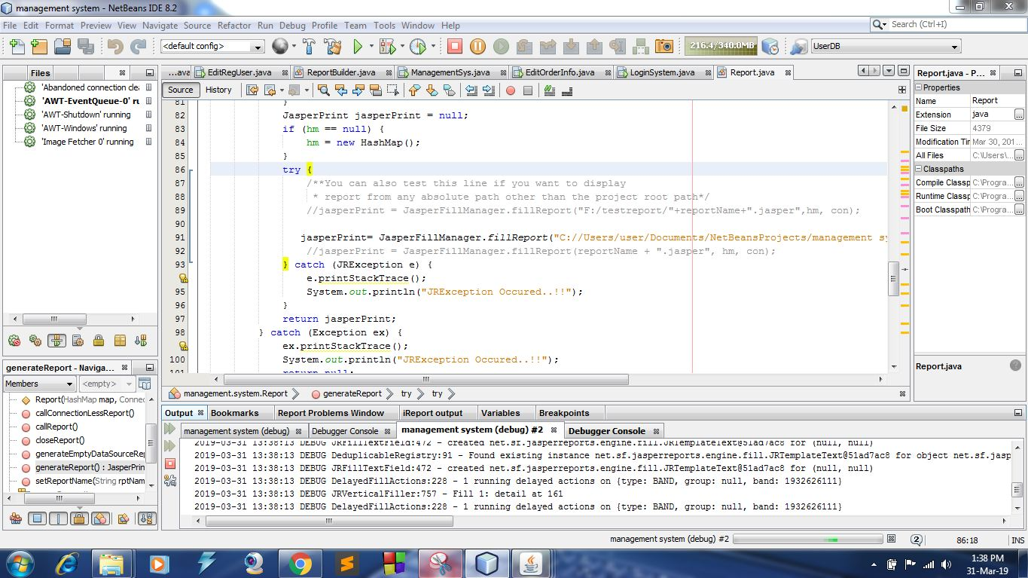

Fig: Debug Run To Test Program

**5. RESULT & DISCUSSION:**

After using this software, we have got some result that is-

* OutStanding performance for business calculate and logic
* Robust, secure & portable
* Easy to use & User friendly
* Customisable
* Integrity feature
* Smart reporting system of invoice
* Dynamic and nice look & feel of UI
* Fast Performance
* Data backup and restore system

**6. MATERIALS AND IDE-TOOLS:**

* Netbean
* MySQL
* Jasper Report [iReport Plugin]
* Sublime Text Editor
* Debuger
* Jdk
* Project Related Jar and Library

**7. PROCESS IMPROVEMENT:**

* Encryption Decryption Cryptography
* Product Key License
* Design Pattern
* Look & Feel of Q-POS
* Login Authentications

**8. FUTURE DEVELOPMENT:**

* Connect to web
* Mobile SMS Service,
* Mail Server,
* Client merchant communication
* web store
* mobile integration
* Online transaction method
* E-commerce

**9. CONCLUSION:**

Because of lightweight , fast & secure of the  software, User will be able to make order and invoice quickly with safety. We hope that this software will contribute in supermarket business inventory much.

**10. REFERENCE :**

* [http://www.netsuite.com](http://www.netsuite.com/)
* http://www.lilyit.com/ m-pos
* <https://stackoverflow.com/>
* <https://community.jaspersoft.com/>
* <https://opensource.org/>
* <https://dzone.com/>
* <https://www.mkyong.com/>
* <https://www.tutorialspoint.com/>
* <https://www.geeksforgeeks.org/>
* <https://hackr.io/>
* <http://www.java2s.com/>
* <https://www.java4s.com/>
* <https://www.javatpoint.com/>
* <https://www.dineshonjava.com/>
* <https://www.roseindia.net/>

**THE END**



|  |  |
| --- | --- |
| **https://lh6.googleusercontent.com/sS0FClSy-q0hyvw2cn4dgANx7Pjt_hz7PFhLUeaAAH9H3PExogFlSsE9_JdMFm6f5oW77p_a1fSjGqiB2z1ghqsVJAGzjTu-f6L1hUmAr6rPp7vEP0tR2eiIjS_Ro4gj38Q_VUDV** | **https://lh3.googleusercontent.com/IMMJaQ7Hlfmiv1R9qeof49B40CYKtRLmHU6MhRsiD5IiW3MMd9ivGmMz9Er9zG_dLgPX96h8jXuE7nsFz5s63Phw5CA6BfxlUY5sSCLIjUqsQk_34FdKzBHw-KgrJvBAU6mdmi5k** |